REGISTRATION FORM OF 7th GCOET CONFERENCE 2019
6-7 December 2019, G Hotel Gurney Penang, Malaysia
http://gcoet.org/pay.html

7th GCOET will be held during 6-7 December 2019, G Hotel Gurney Penang, Malaysia. Please note that it is essential for all participants to email the filled Registration Form (.doc/.docx/pdf) along with Proof of payment receipt to ids: admin@gcoet.org and Cc to register@gatrenterprise.com

SECTION 1: CONTACT INFORMATION
Paper ID Code: For example, GCOET-00101
Name that you would like to get printed on the certificate:

Conference Title: 7th Global Conference on Engineering and Technology, Penang, Malaysia.
Whether attend the Conference: € Yes € No
Position (Professor/Associate Prof/Assistant Professor/Lecturer/PhD Student/Master Student/other):

Full Affiliation/Organization/University and country Name:
(that you like get printed on the certificate)

Broad Field: i.e. Civil |  | Are you willing to serve as a session chair:(Yes (No
Session Type: € Oral Presenter € Participant (Without paper) € Visual Presenter
Telephone: | Mobile: |  |  | Email:
Special Needs or Dietary Requirements: € Yes € No
Student ID Number of Your University (if applicable):
Paper Title:
Paper Pages: |  | Additional Page:
Are you interested to join Conference Tour: |  |  | € Yes € No
Are you interested to attend GALA Dinner & Networking: |  |  | € Yes € No
Are you interested to attend Workshop: |  |  | € Yes € No
Are you interested to join Academic Discussion Session: |  |  | € Yes € No

Notes:
- One regular registration can cover a paper within 8 pages, including all figures, tables, and references at 1.5 line spacing. If the length exceeds 8 pages the authors are required to pay a publication fee of USD 25.00 for each additional page.

- If number of authors are more than two in manuscript authors are required to pay additional fees USD 50 for each additional author name.

- For additional Certificates for co-authors needs to pay USD 100 for each additional certificate.

SECTION 2: REGISTRATION FEESINFORMATION

Fee Schedule for 7th GCOET Delegates: | Early  Until: 12/09/2019 | Normal  Until:  17/10/2019 | Late  Until: 21/11/2019
Regular Presenter (Lead Author) / Co-author | USD 500 | USD 550 | USD 575
Visual Presenter (Using Skype) | USD 500 | USD 550 | USD 575
Full Time Student (Proof of Student ID is compulsory) | USD 400 | USD 450 | USD 475
Additional Paper (by same Presenter) | USD 300 | USD 325 | USD 350
Participant (Without paper) | USD 300 | USD 400 | USD 425
Additional Events for 7th GCOET Delegates:
Deans and Directors Networking Session & Discussion on 6 December 2019 | FREE | FREE | FREE
Workshop on Publishing in High Impact Factor (SSCI & SCI) Indexed Journals on 7 December 2019 | USD 75 | USD 110 | USD 120
Penang Tour on 6 December 2019  (6:00 PM to 8:30 PM) | FREE | FREE | FREE
GALA Dinner & Networking on 7 December 2019 | FREE | FREE | FREE

GATR/GCOET Policy:

- The lecturer cum student will not be considered for student rate
- A full-time student must need to submit a valid student ID card and letter of recommendation Dean/advisor.
- Daily Market Conversion Rate is applicable to all USD prices.
- Service/Transfer Fees are not included in above prices.

Registration fee of Regular/Visual/Student Presenter Included:

- Academic Discussion Session
- Card holder, Printed name card
- Conference bag & Pen
- Printed presenter certificate
- Refereed Proceeding CD with ISBN
- Journal publication fees (Sponsored by GATR)
- Printed program Schedule
- Two coffee breaks each day
- International Buffet lunch daily
- GALA Dinner
- Penang Tour

Registration fee of Observer Included:

- Card holder, Printed name card
- Conference bag & Pen
- Printed program Schedule
- Two coffee breaks each day
- International Buffet lunch daily
- GALA Dinner
- Penang Tour

SECTION 3: PAYMENT INFORMATION

Option 1

You can pay registration fee by Bank Deposit / ATM Transfer / Online Transfer / Telegraphic Transfer in Company official account.

Please Visit: http://gcoet.org/pay.html
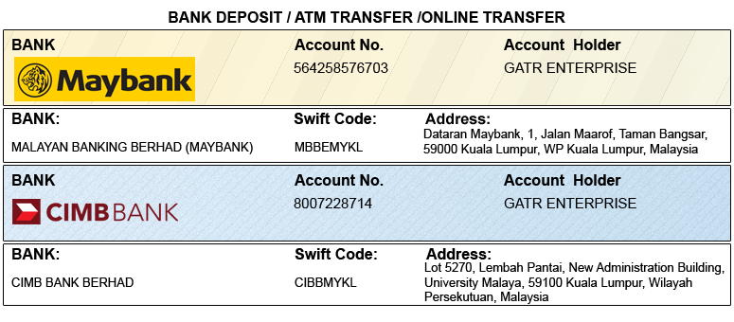

Option 2

You can pay registration fee through 2checkout Credit Card /Debit Card/PayPal in Company official account.

Please visit: http://gcoet.org/pay.html

PRIVACY POLICY:

The Global Academy of Training & Research (GATR) Division will protect your personal information. Your personal information received will only be used to fill your order. We will not sell or redistribute your information to anyone.

CANCELLATION POLICY:

You may cancel without penalty if written cancellation request is received up to and including 45 days prior to the start of the conference. A credit voucher less 50% of the registration fee will be issued for written requests received up to and including 25 days prior to the start of the conference. No refunds or credits will be issued on cancellation requests received less than 25 days prior to the start of the event. No liability is assumed by Global Conference on Engineering and Technology for changes in program, date, content, speakers or venue.

PLEASE NOTE: Original receipts will be emailed to register guest before conference for claim purposes.

Declaration: I agree that I cannot claim back the registration fee I paid under any circumstance.
SIGNED:  (or write name here) |  | DATE:

